**MOBILE AD-HOC NETWORK(MANET)**

**Definition:** A mobile ad hoc network (MANET) is a continuously self-configuring, self-organizing, infrastructure-less, network of mobile devices connected without wires. It is sometimes known as "on-the-fly" networks or "spontaneous networks".

Broadly defined, a mobile ad hoc network is a group of wireless nodes (which aren’t routers) that cooperatively form a network that operates without the support of any fixed infrastructure. MANETs usually have a routable networking environment on top of a [*Link Layer*](https://en.wikipedia.org/wiki/Link_Layer)ad hoc network. MANETs consist of a peer-to-peer, self-forming, self-healing network. MANETs circa 2000–2015 typically communicate at radio frequencies (30 MHz – 5 GHz).

**Why is there a need of this kind of network?**

Hurricane Katrina, August 2005

1. Over 3,000,000 phone lines went down, 2000 cell towers knocked out
2. Land Mobile Radio (LMR) communications degraded
3. Ham radio operators assisted 911 dispatchers
4. Field reporters exchanged information between victims and authorities

Haiti earthquake, January 2010

1. Public telephone service and Digicel and Comcel cell networks went down
2. Haitel cell network quickly overloaded, partially by Red Cross volunteers
3. Fiber-optic networks disrupted
4. Cell towers collapse, lose power, or quickly become overloaded
5. Landlines become disconnected from PSTN exchange offices
   1. Public telephone network and Internet service loss
6. Cell towers, PSTN offices, wireless APs, etc. are single points of failure in a centrally managed communications infrastructure
7. These single points of failure all provide a convenient mechanism to sniff / filter user traffic and perform MITM attacks

**Solution:**

* Leverage the ubiquity of smart phones to create a P2P mesh network
  + 46% of American adults are smart phone users (up 11% from May 2011) [1]
  + Network is headless, does not depend on cell towers or wireless APs
  + Relay messages through peers, forming routing chains
  + Network dynamically expands as more peers join
  + Network is self-healing, peers can leave at any time
  + Share information across the Mobile Ad-Hoc Network (MANET) when infrastructure is broken or cannot be trusted
  + Form a P2P VPN over the mesh to secure communications
  + Route data through trusted peer devices
  + Nodes can act as gateway devices to connect the mesh to existing infrastructure as it becomes available
  + Share your cell phone service for your specific carrier

**Implementation:**

Algorithms that are related to MANET, some that are clinically designed for MANET are:

* OLSR (OPTIMISED LINK STATE ROUTING)
* AODV(AD-HOC ON DEMAND DISTANCE VECTOR)
* DSR(DYNAMIC SOURCE ROUTING)

**OLSR:**

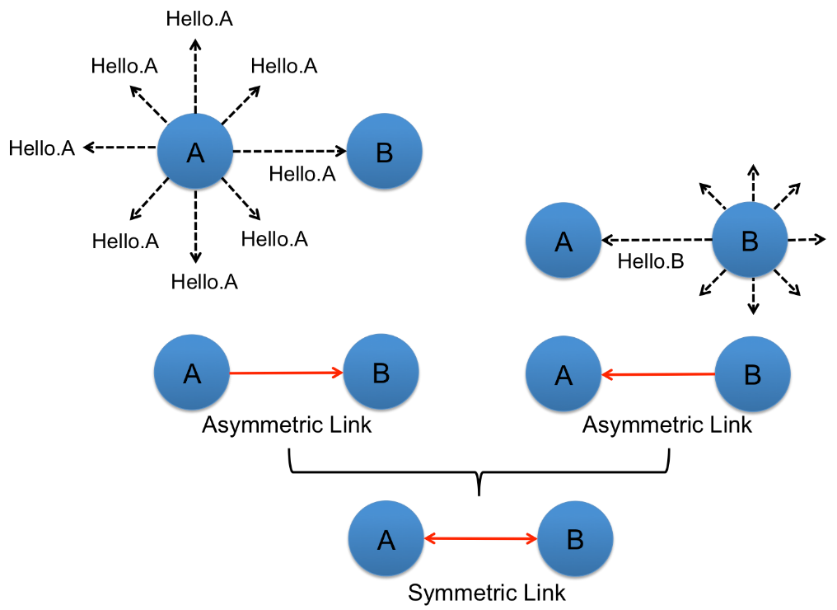

* Pros
  + Better than everyone sharing everything
  + Topology info dumps only between MPRs
  + Incremental improvements
* Cons
  + MPRs are throughput choke points
  + Entire routes planned in advance, but next hop uses its own route